**Version 1.1, 10/27/21  
  
Skytap to Azure ExpressRoute - Customer Managed**

Goals of this tutorial:

1. Define an ExpressRoute Circuit in Azure
2. Connect ExpressRoute to the Skytap service
3. Define a VM or LPAR in Skytap to communicate with a VM in Azure
4. Define a VM in Azure to communicate with Skytap
5. Test the connection between the LPAR in Skytap and the VM in Azure

*Backgroud: IBMi Power infrastructure supporting AIX of IBMi is installed in select Azure Regions. The Skytap for Azure service (SOA) allows you to provision LPARs directory from your Skytap subscription.*

*An ExpressRoute must be used to connect the SOA Power Infrastructure to other Azure services. This document describes how you can define an ExpressRoute so your AIX or IBMi resources can communicate with other Azure resources. If you exactly follow the steps below you will have a working example of an AIX LPAR running on Skytap, communicating with a Linux VM running in Azure.  
  
Use this tutorial as a guide to help you define your final working environment. This example uses an AIX LPAR "standard image" that is already defined in SOA. In a more advanced scenario, it is possible to import existing on-prem images instead of using default template images.****Recommendation****: First follow the steps below to see the process of how you make Power resources communicate with Azure native resources. Once you have this completed, then work on how to import your existing LPAR images.*

Links referenced by this tutorial:  
  
How to provision a base ExpressRoute in Azure

<https://docs.microsoft.com/en-us/azure/expressroute/expressroute-howto-circuit-portal-resource-manager>  
  
Create a customer-managed ExpressRoute connection inside of Skytap

<https://help.skytap.com/wan-create-self-managed-expressroute.html#creating-a-customer-managed-expressroute-circuit-for-a-private-network-connection>  
  
How to edit a WAN(ExpressRoute) connection inside of Skytap

<https://help.skytap.com/wan-create-expressroute.html>  
  
  
Pre-Requisite Steps (define Skytap Subscription)

1. Create the Skytap Subscription as defined [here](https://help.skytap.com/creating-a-skytap-on-azure-account.html#adding-a-skytap-on-azure-subscription-to-your-microsoft-azure-account), or access a previously defined Skytap subscription that exists for you in the Azure Marketplace.  
   The link is:  
   <https://help.skytap.com/creating-a-skytap-on-azure-account.html#adding-a-skytap-on-azure-subscription-to-your-microsoft-azure-account>
2. If the above step was completed, you should end up at a screen that looks like this:  
   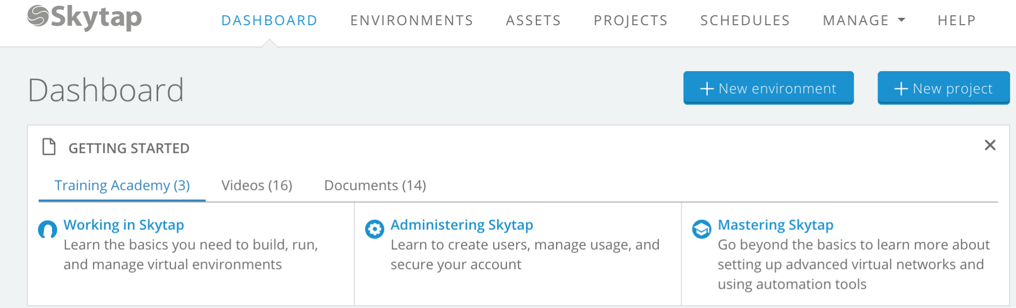  
   This is your starting point for the Skytap part of the procedure.

PHASE "A": Define an ExpressRoute Circuit in Azure

1. Switch over to the Azure Portal, define the ExpressRoute connection:  
     
   From Azure search for "ExpressRoute circuit" and click the button:  
     
   Fill out the form with these values:  
   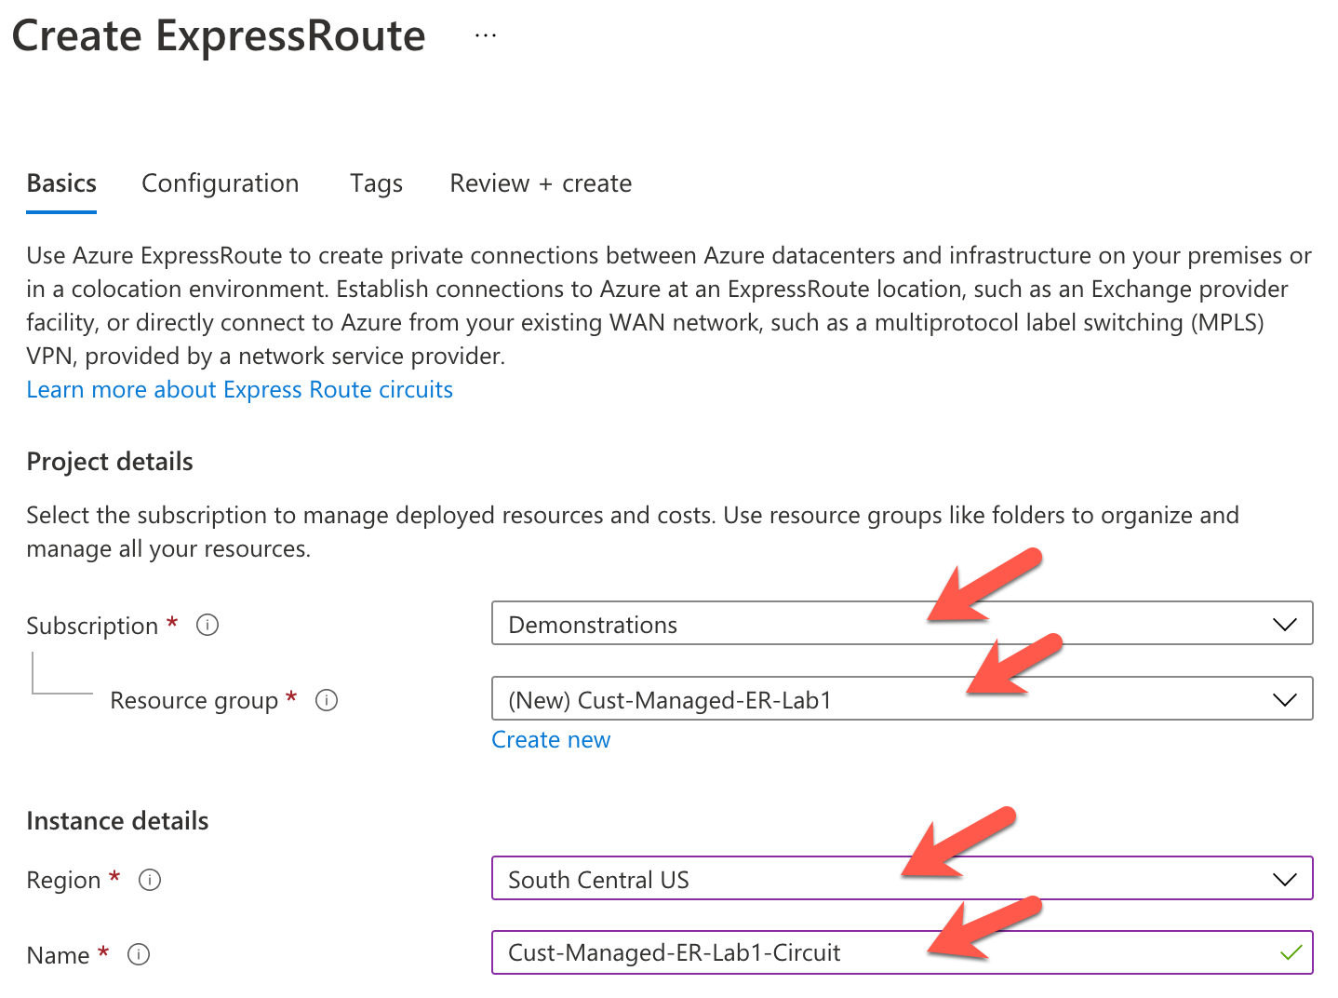  
     
   Press this button:  
   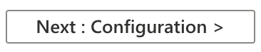
2. Fill out the configuration page like this:  
   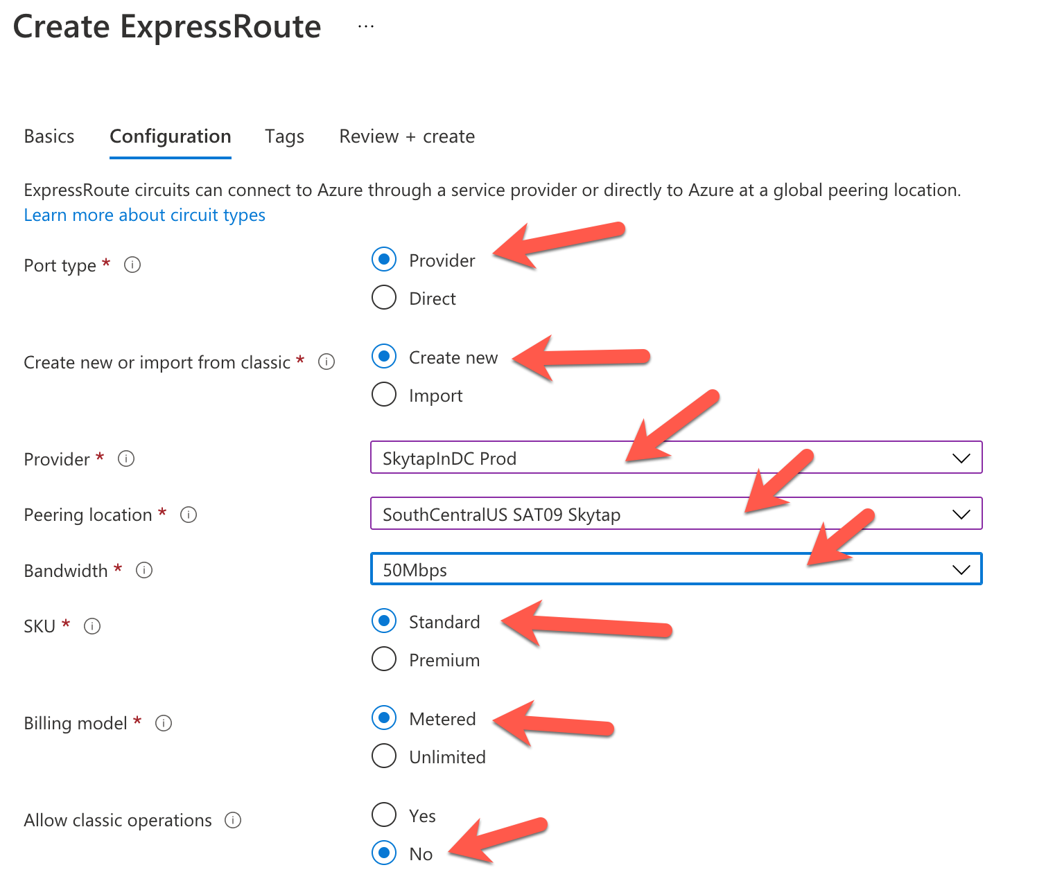  
     
   NOTE: the value of "50Mbps" is used for example purposes in this tutorial. Adjust to your desired value if using this guide to create a production connection.  
     
   Press this button:  
   
3. On the confirmation/validation page, pick "Create":  
   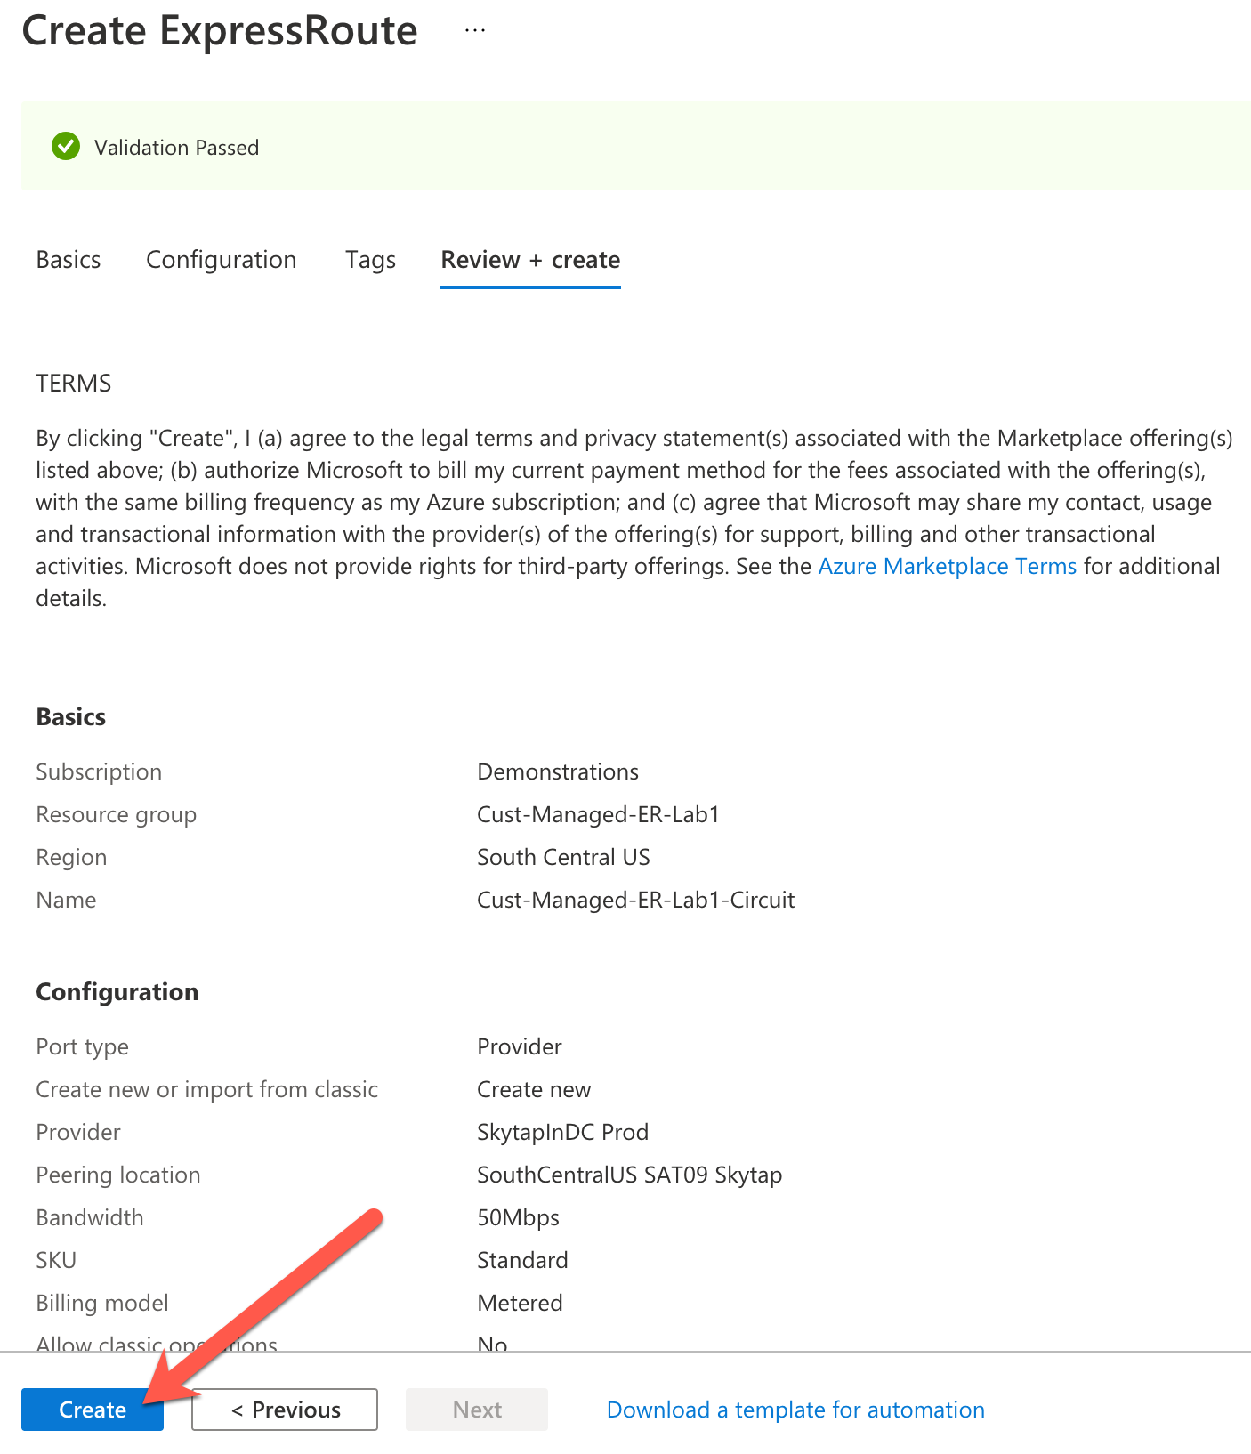
4. Wait for the resource to be created, once done "Go to resource"  
   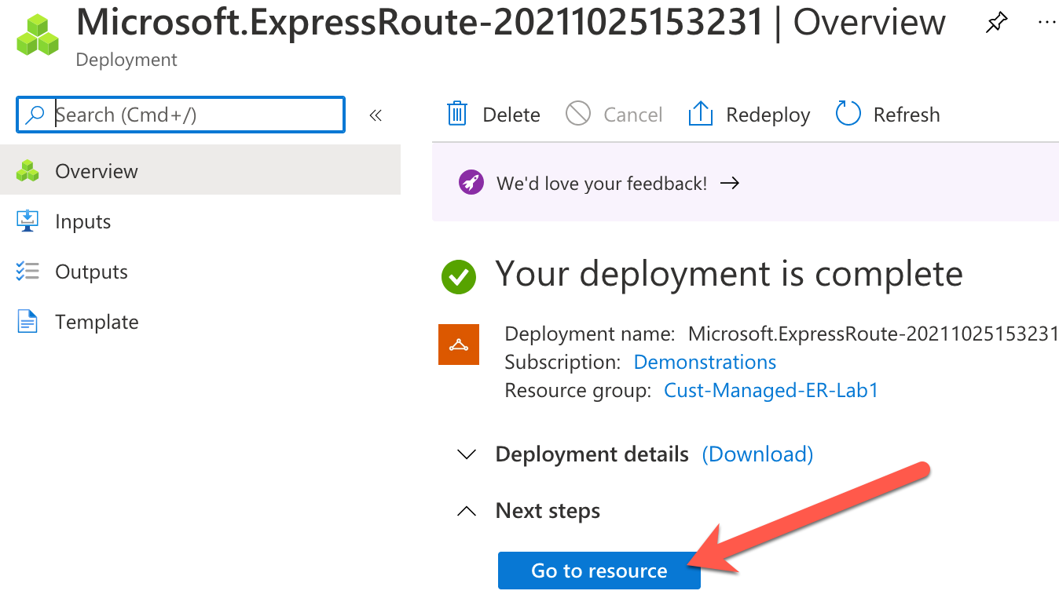
5. On the resource definition page, make note of the "Service Key", the hexadecimal string will be used in the next section:  
     
   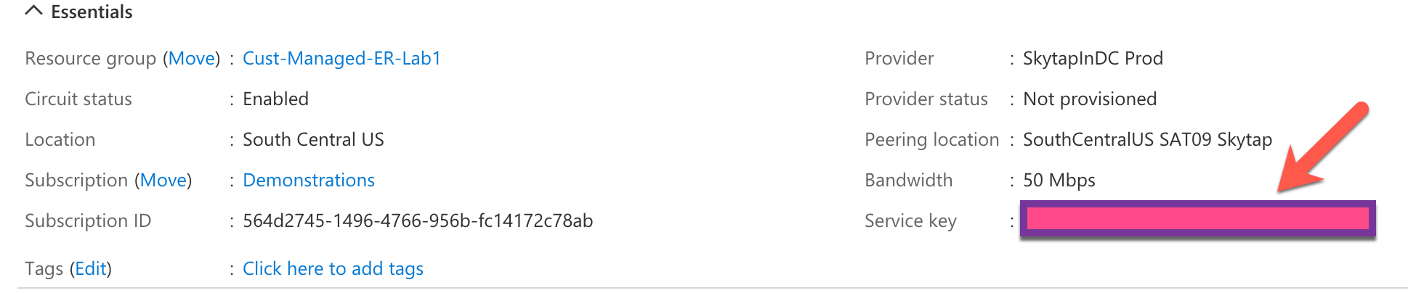

PHASE "B": Connect ExpressRoute to the Skytap service

We will now define the ExpressRoute termination point for the Skytap service. Follow these steps:

1. From the Skytap Dashboard page, look along the top and select "MANAGE" and then "Public IPs"  
     
   Allocate a new Public IP Address:  
   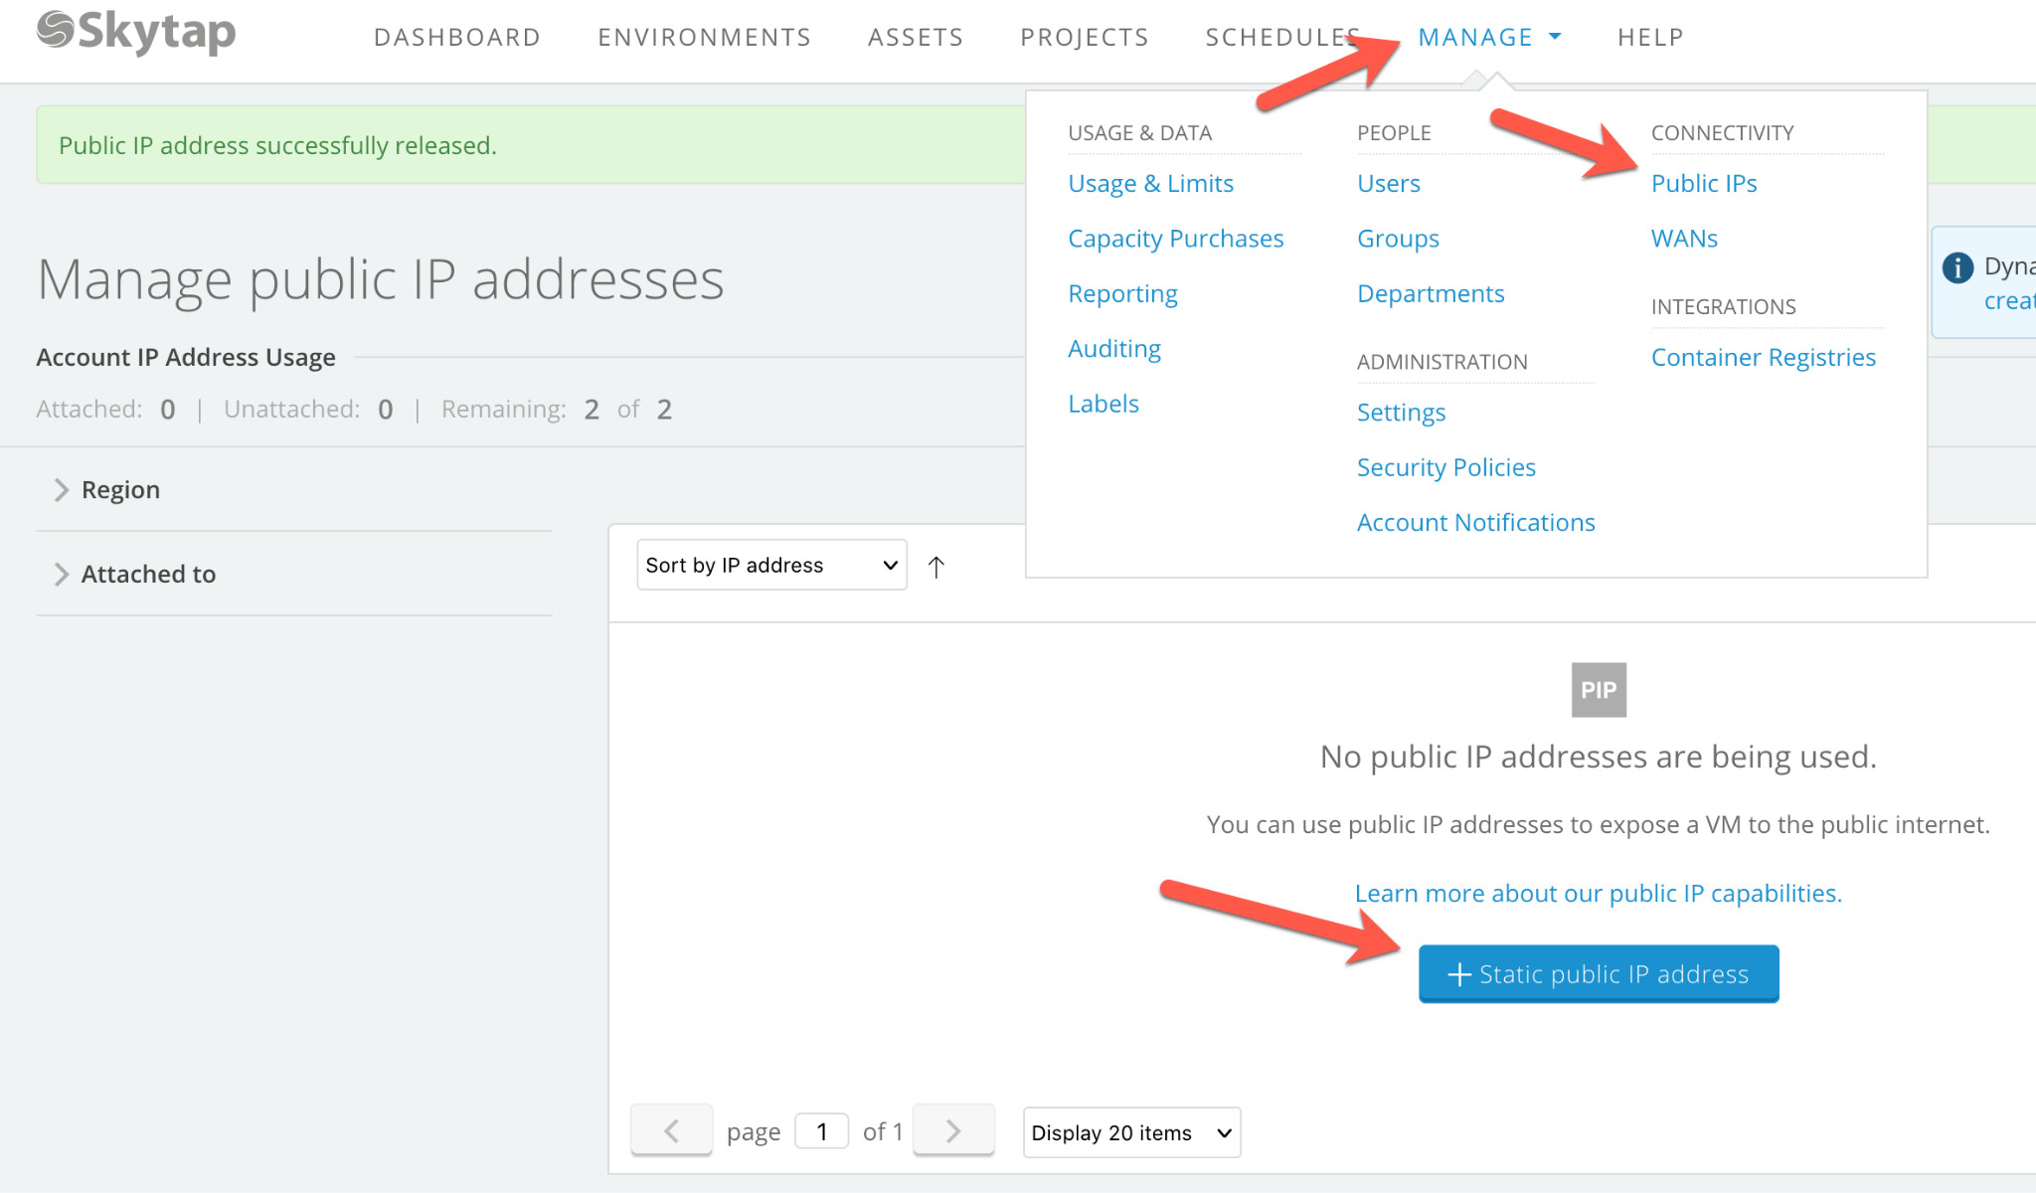  
     
   Once done, you will see that IP listed on the page, this IP will be used in the next step.  
   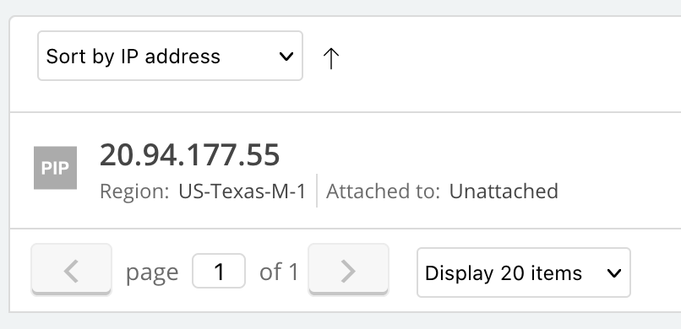  
     
   **NOTE: Even though the Skytap portal says "PUBLIC" IP, this IP will actually be privately used for the ExpressRoute connection, no traffic will pass over the public internet.**
2. From the Skytap Dashboard page, look along the top and select "MANAGE" and click then "WANs", then click "New Private Network Connection".  
   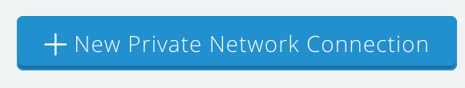  
   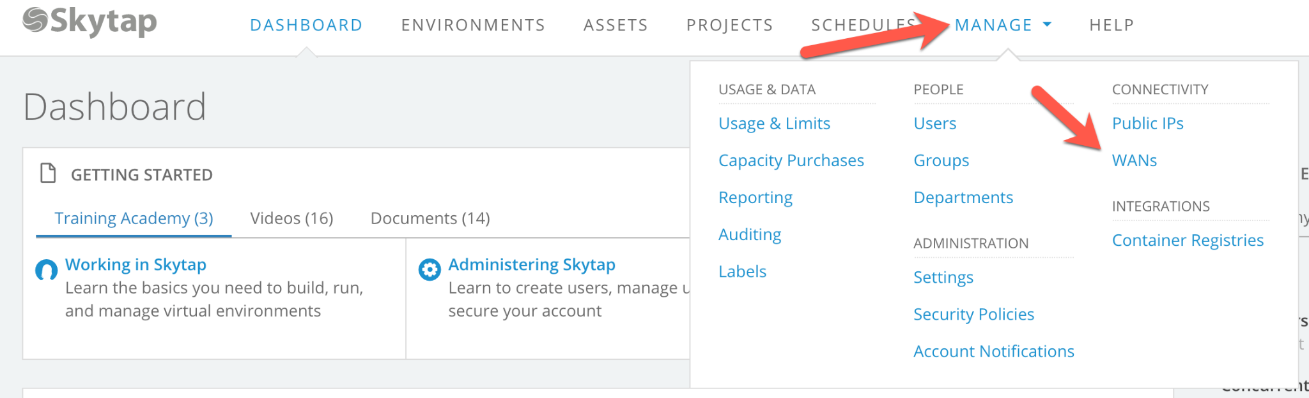
3. Fill out the page with the following values:  
   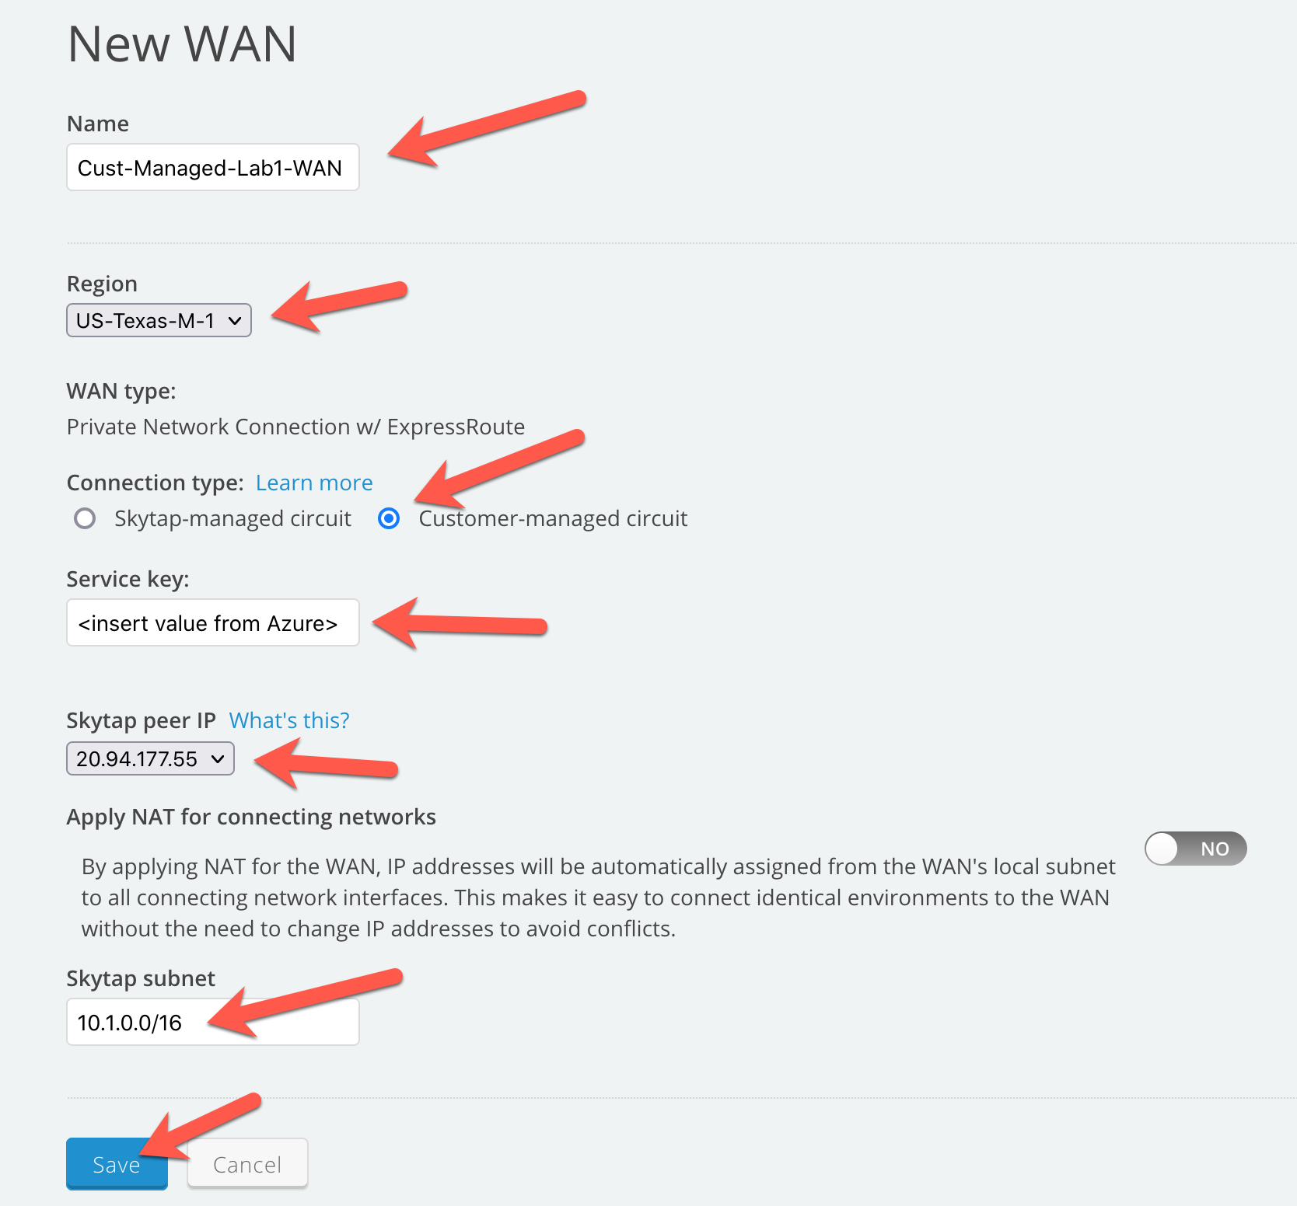  
     
   NOTES:   
   a) Pick "Customer-managed circuit"  
   b) Copy/paste the hex-string value from the ExpressRoute defined in the Azure Portal  
   c) Confirm the IP address that was allocated in the previous step  
   d) Change the subnet to "10.1.0.0" from the original value of "10.0.0.0" (for tutorial purposes only.)

e) **IMPORTANT: Keep track of the "Skytap Peer IP" address. This will be used later in the definition of the Azure side of the ExpressRoute. (20.94.177.55)**  
  
Press the SAVE button.

1. The page will show "Provisioning state" = "Pending", wait for that to complete:  
   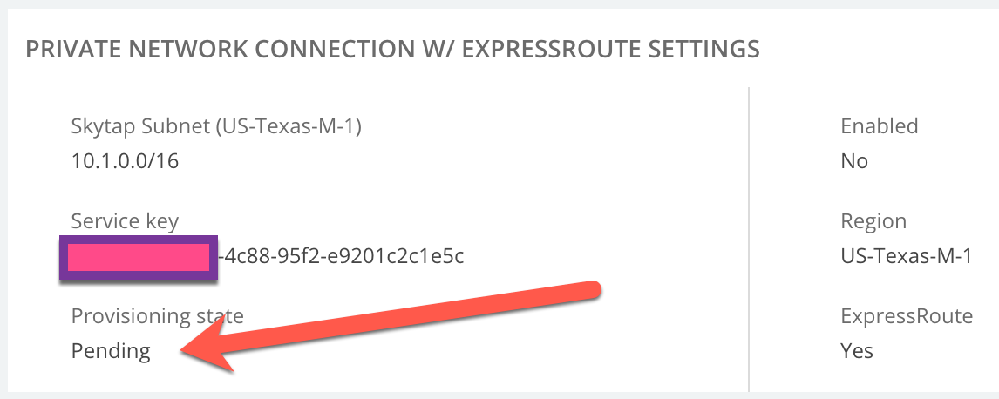  
   Once complete the page will switch to:  
   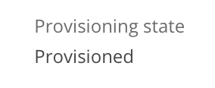
2. While on this same page, add a remote subnet with a value of "0.0.0.0/0" which will pass all traffic over the ExpressRoute. Read up on this value when you have a more complex setup, but for this tutorial, enter "0.0.0.0/0" and press the "Add" button:  
     
   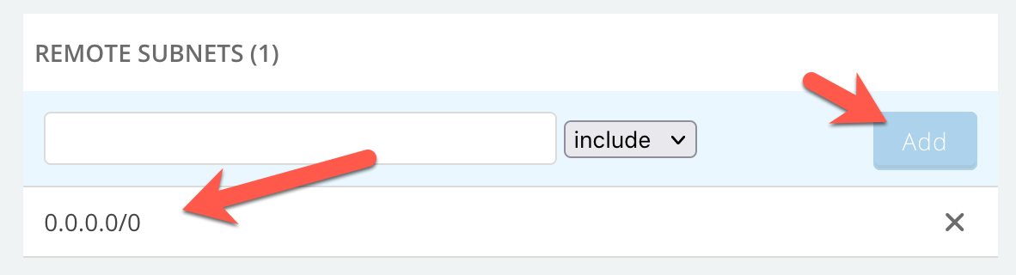
3. Refresh the browser page with the WAN definition on it, you should be able to press the "Enable" button to enable the WAN connection:

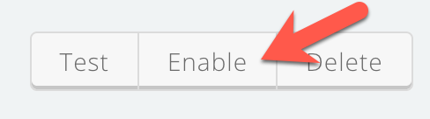  
  
After a few moments, the status will be switched to "Enabled".

Phase C: Define a VM or LPAR in Skytap to communicate with a VM in Azure

Now define an LPAR in Skytap and a VM in Azure and make them talk to each other.

1. Click "DASHBOARD" then "New Environment":  
   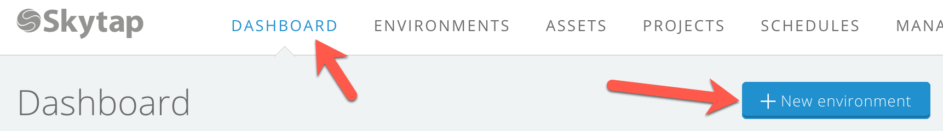
2. Type "AIX", press <ENTER> and pick "AIX 7.2, then click "Create Environment"  
   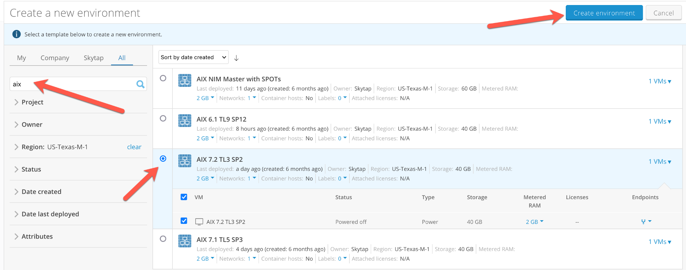
3. Change the network definition to use subnet "10.1.0.0" to match our ExpressRoute definition created earlier. The current value should be "10.0.0.0", change it to "10.1.0.0":  
   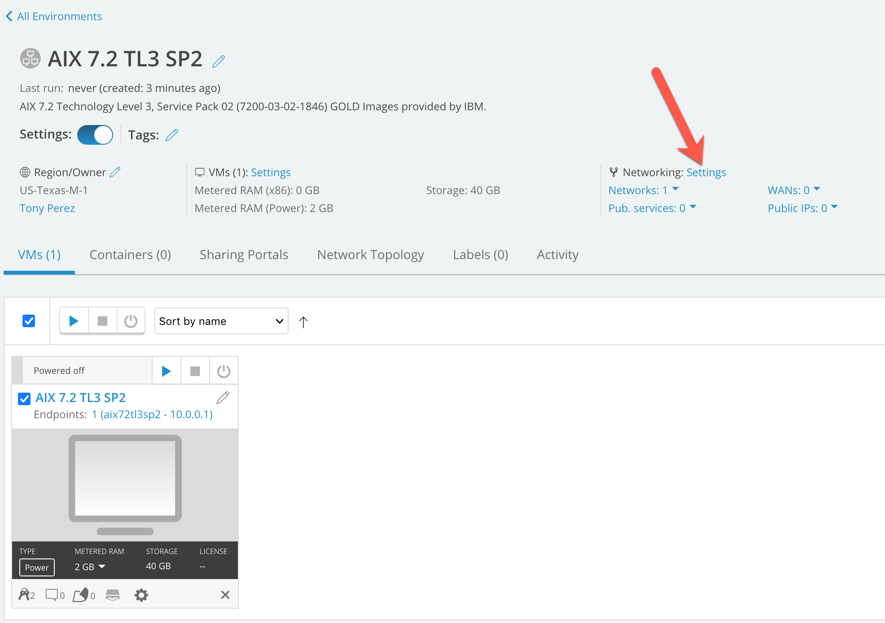  
     
   Click "Edit Network"  
   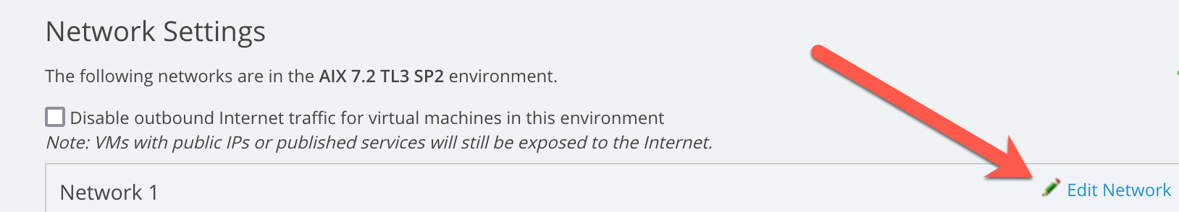  
     
   Change the values to be:  
   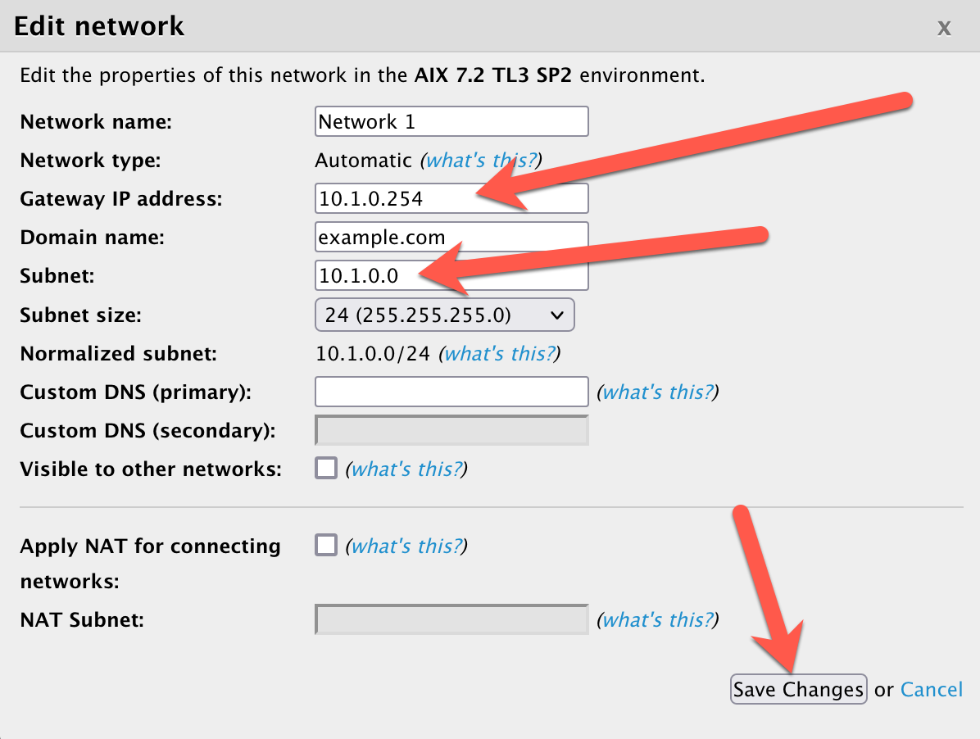
4. Click "Back" to go back to the environment page  
   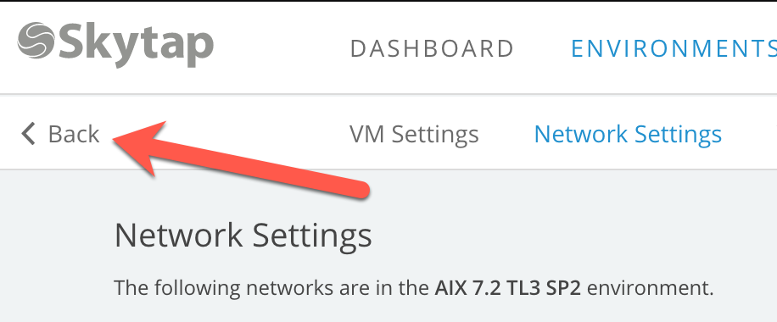
5. Now start the AIX LPAR by clicking the run button:  
   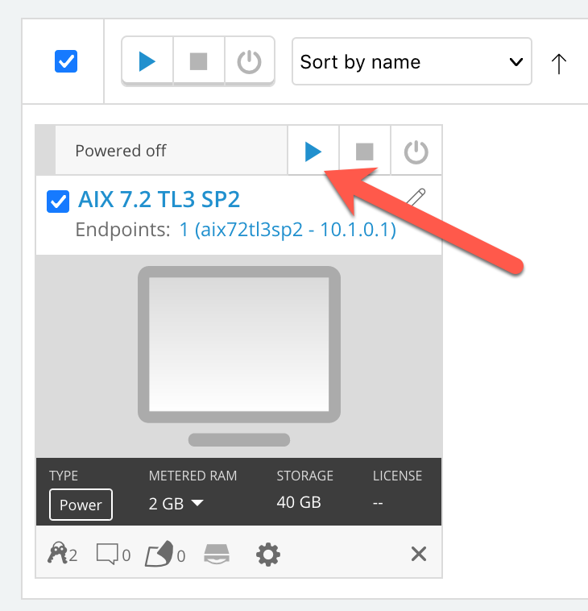
6. Wait for it to turn color "green", which means it is fully running. It will take a few minutes to start up once you hit the run button:  
   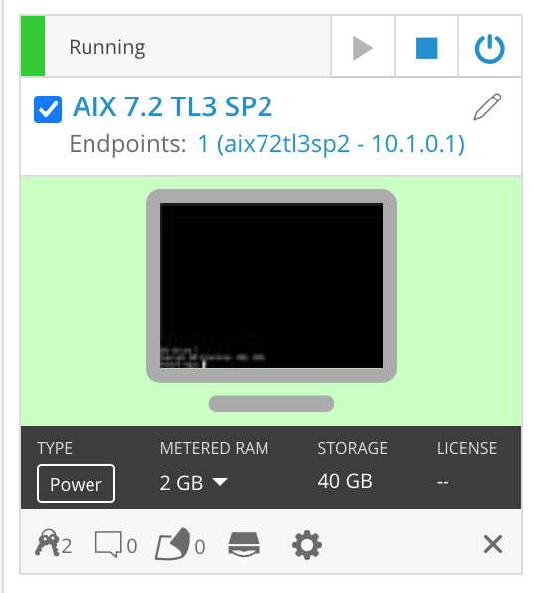
7. Attach the network that the LPAR is running on to the ExpressRoute WAN connection:  
   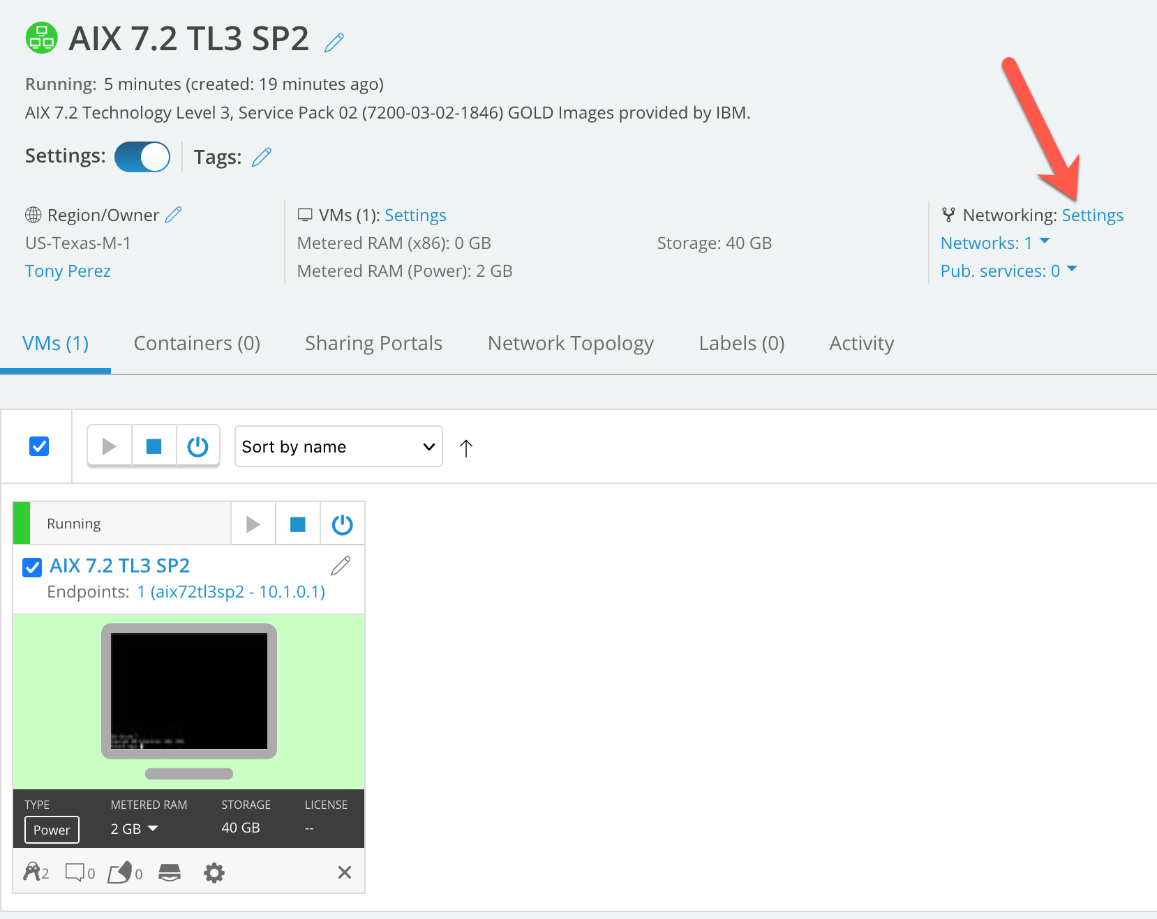
8. Connect it to the WAN:  
   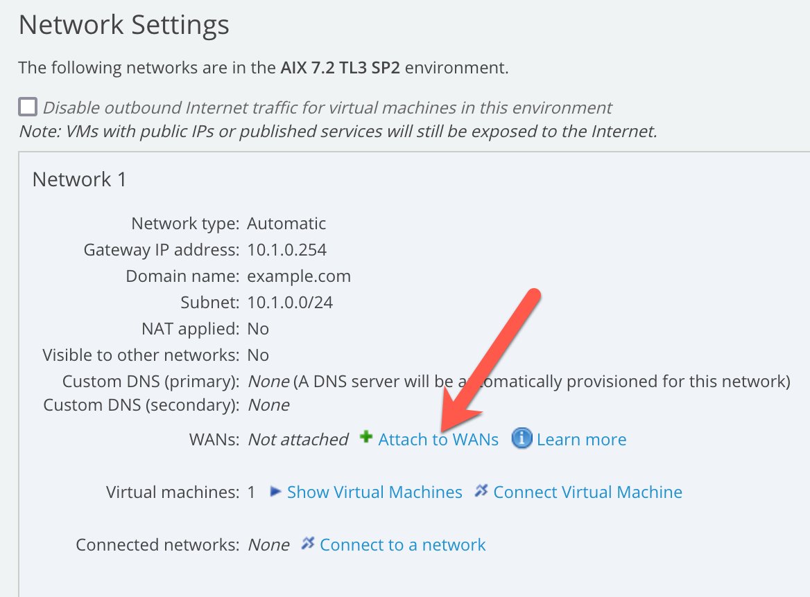
9. Click on "Attach" and the click on "Connect":  
   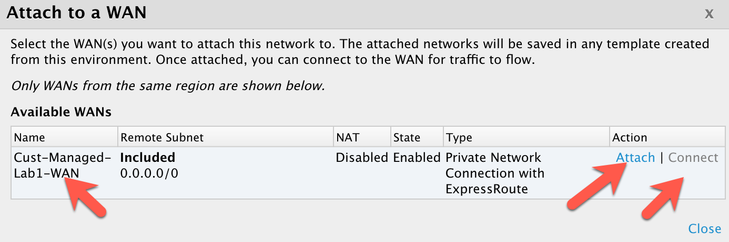
10. When finished the page should look like this:  
    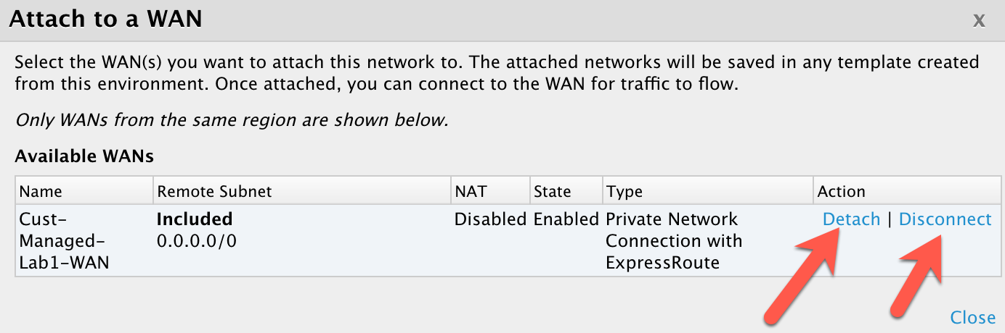

Phase D: Define a VM in Azure to communicate with Skytap  
  
Now define the components in Azure to support a network and VM that can be connected to the Azure side of the ExpressRoute:

1. Create a Virtual Network to attach to the previously create ExpressRoute in the Azure portal:  
     
   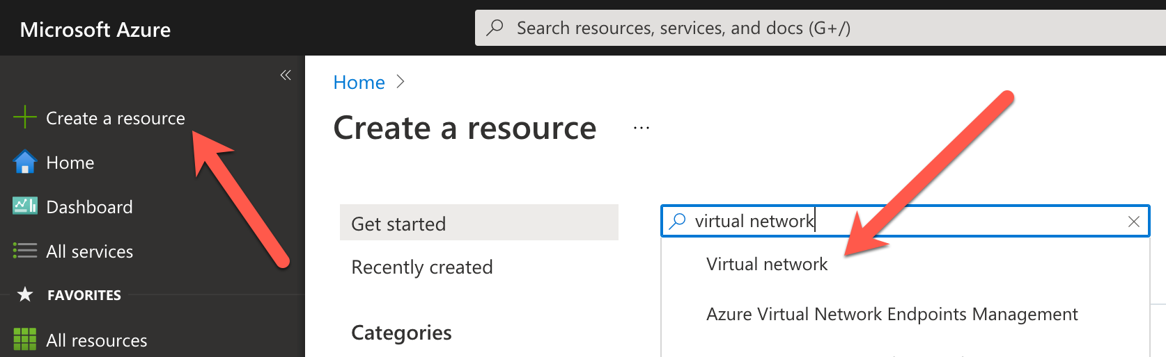
2. Fill out the page with the following values:  
   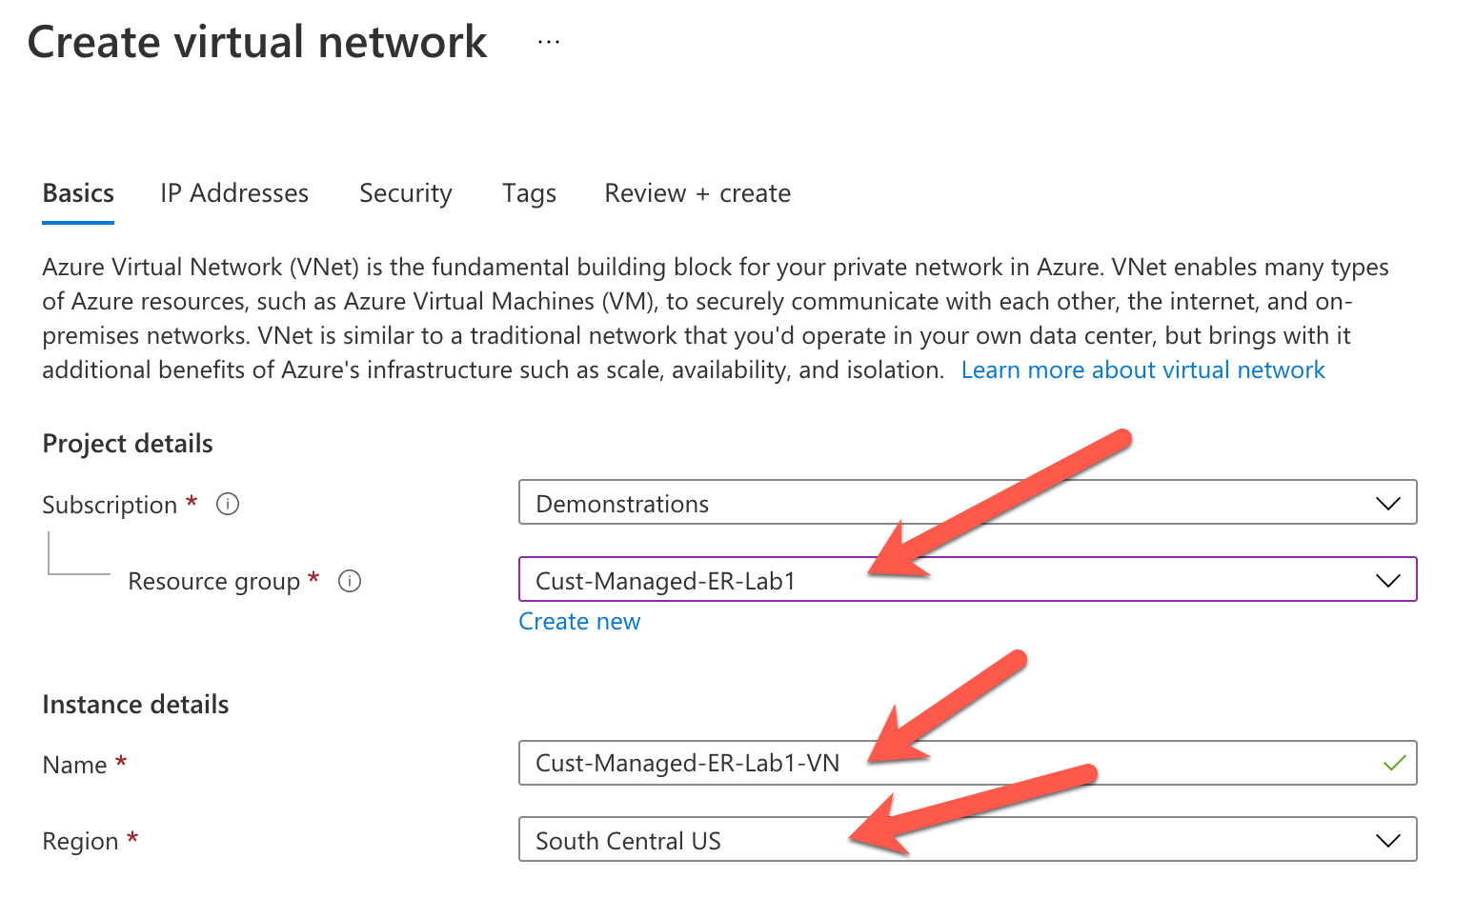  
   Click: "Next: IP Addresses"  
   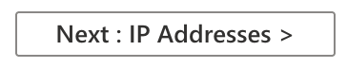
3. Accept the default values presented by the Azure portal:  
   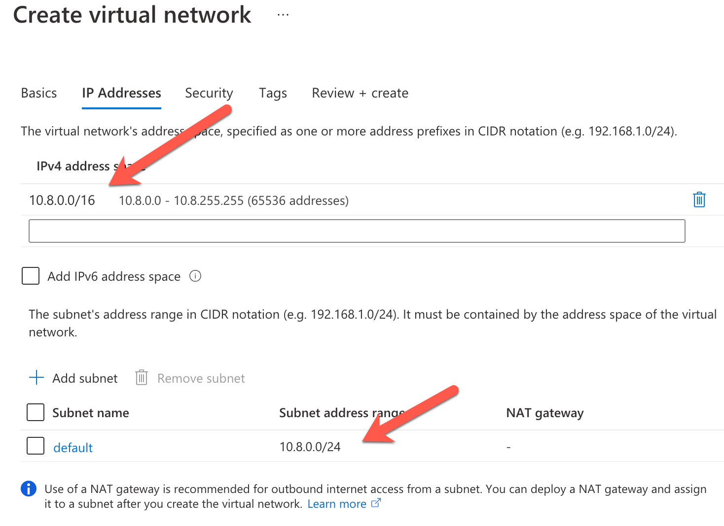  
   Click "Next: Security>"
4. Leave the default values:  
   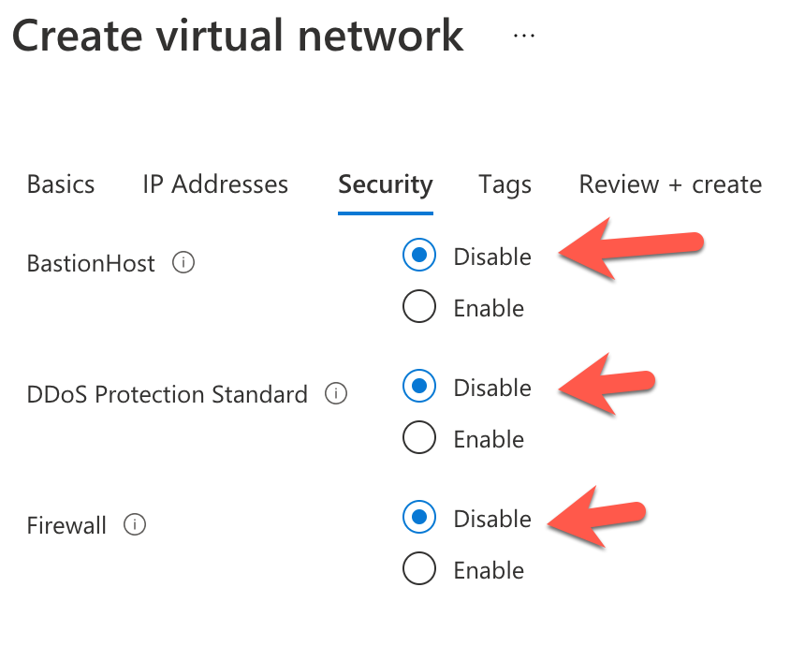  
   Click "Review + Create"
5. Once the validation is complete click "Create"  
   
6. Create a Virtual Network Gateway:  
   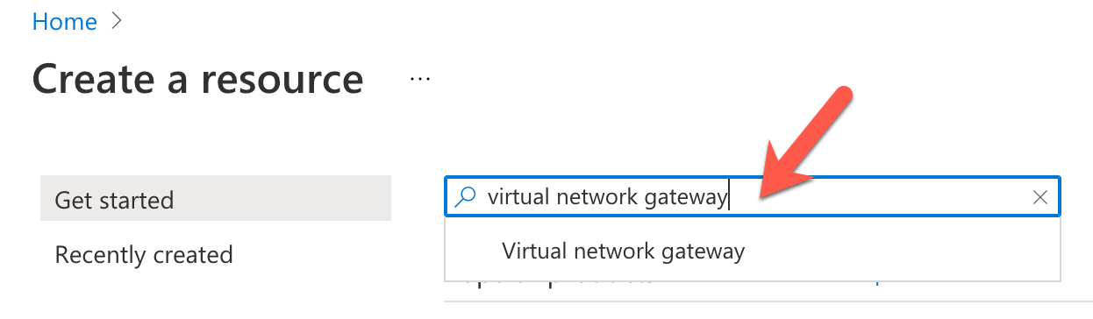
7. Use the following values:  
   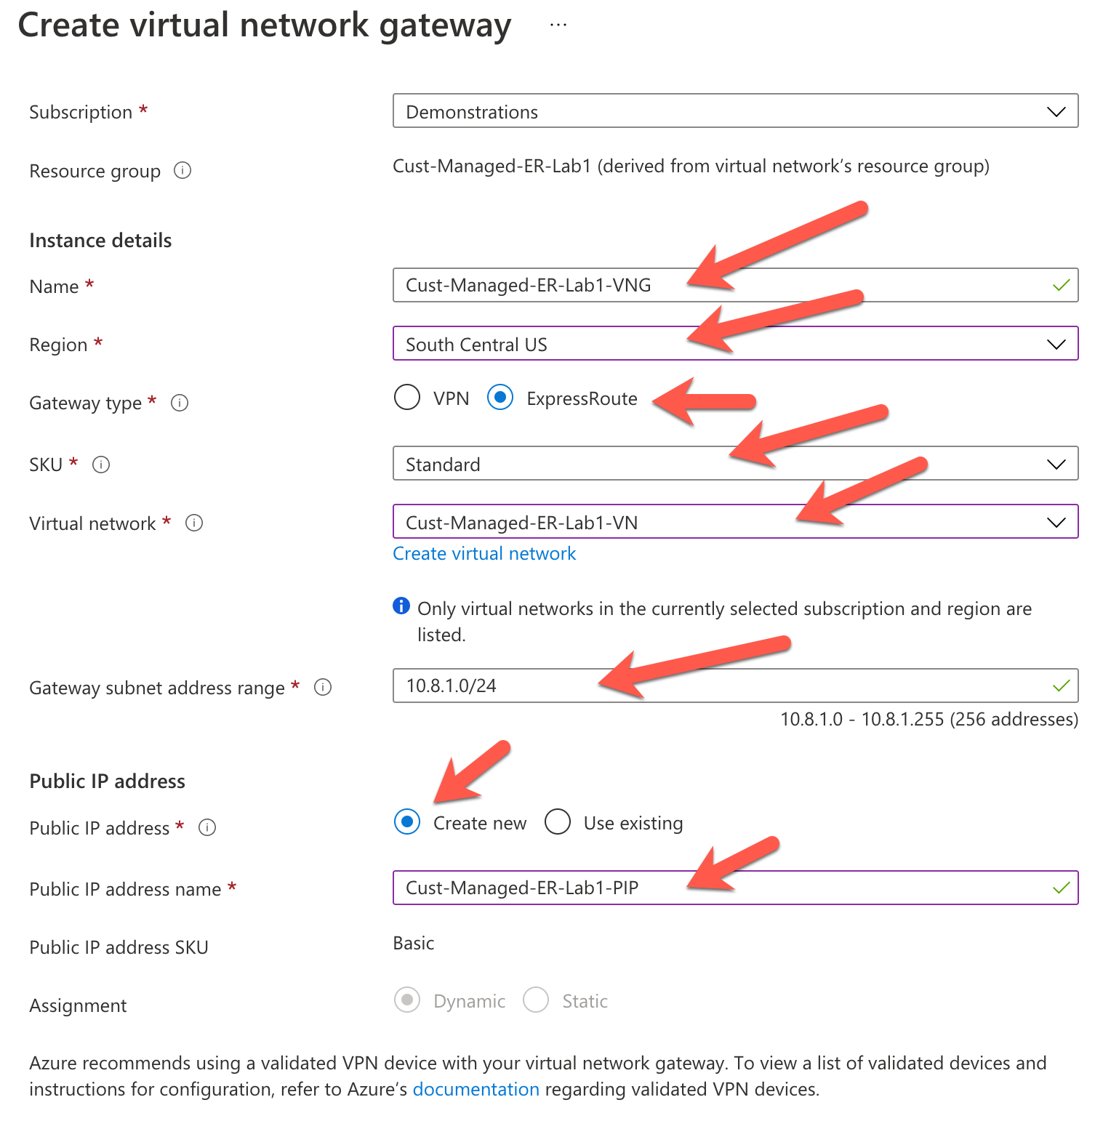  
   Click "Review + create"  
     
   After the validation is finished, click "Create":  
   
8. Define and create a Local Network Gateway

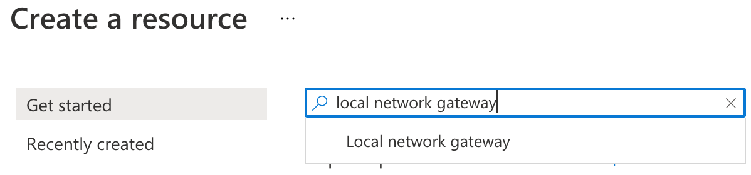

1. Fill out the page with the following values:  
   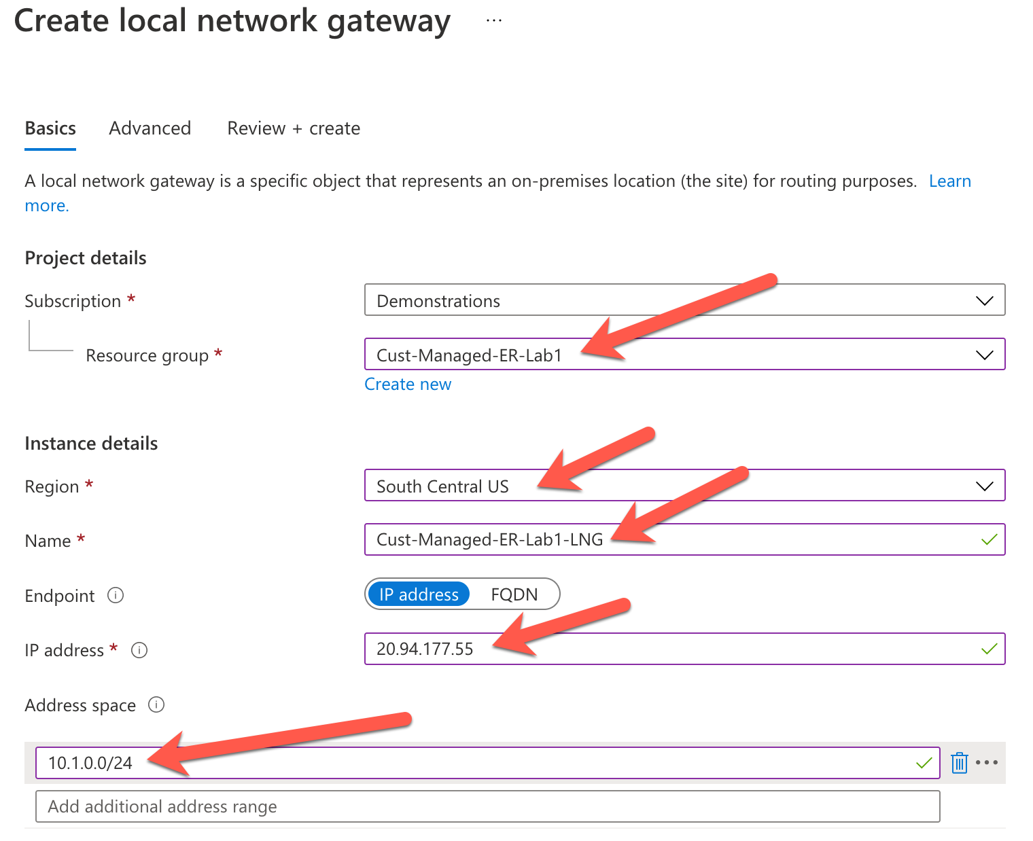  
   NOTES:  
   20.94.177.25 is the IP endpoint defined for the Skytap side of the Express Route Connection. This is called the "Skytap Peer Address" on the Skytap WAN definition screen.  
   10.1.0.0/24 is the subnet that the AIX LPAR exists on that was defined earlier.
2. Click "Review + create" and create the Local Network Gateway. After validation is complete, click "Create". The deployment in Azure takes a few minutes.
3. Combine all the components into the Virtual Network Gateway defined earlier.
4. Search for your Virtual Network Gateway (VNG) defined earlier:  
   "Cust-Managed-ER-Lab1-VNG"
5. Click "Connections", then click "Add"
6. Fill out the page like the following:  
   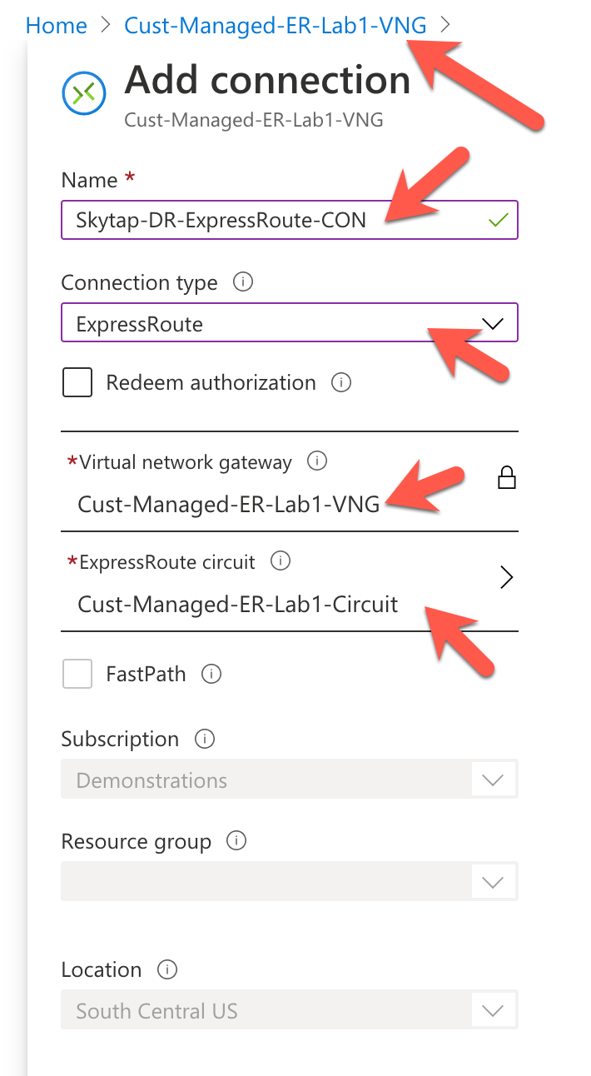
7. Press "OK" on the bottom of the page.
8. Wait for "Creating Connection to Complete"

Phase E: Test the connection between the LPAR in Skytap and the VM in Azure

Now create a VM in Azure, attach it to our Vnet which has the ExpressRoute circuit attached to it and see if you can ping from the AIX LPAR to the Azure VM.

1. Create a new virtual machine:  
   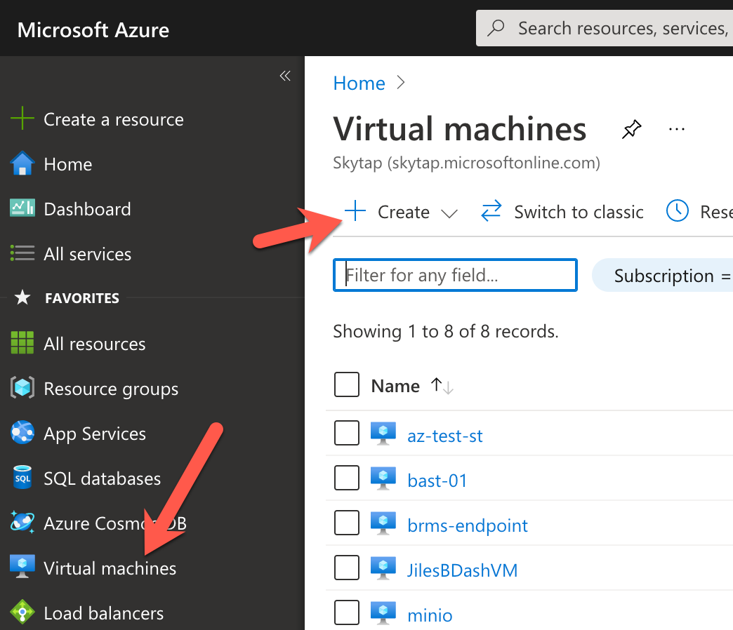
2. Fill out the page like the following:  
   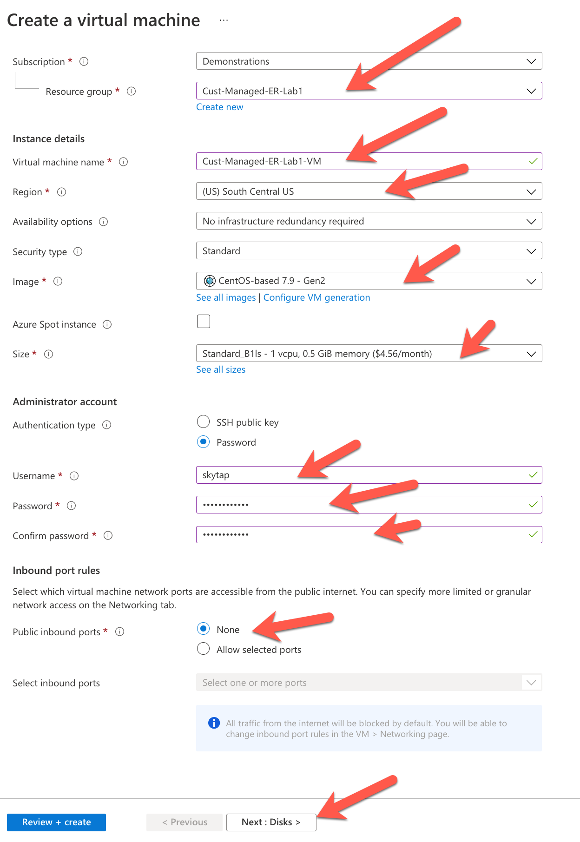  
   NOTES:  
   For this tutorial, set the user to use simple password.  
   No public inboard ports are needed since we will talk to the VM over the private ExpressRoute Connection.
3. Press "Next: Disks>"  
   Select "Standard HHD" (cheapest for tutorial)  
   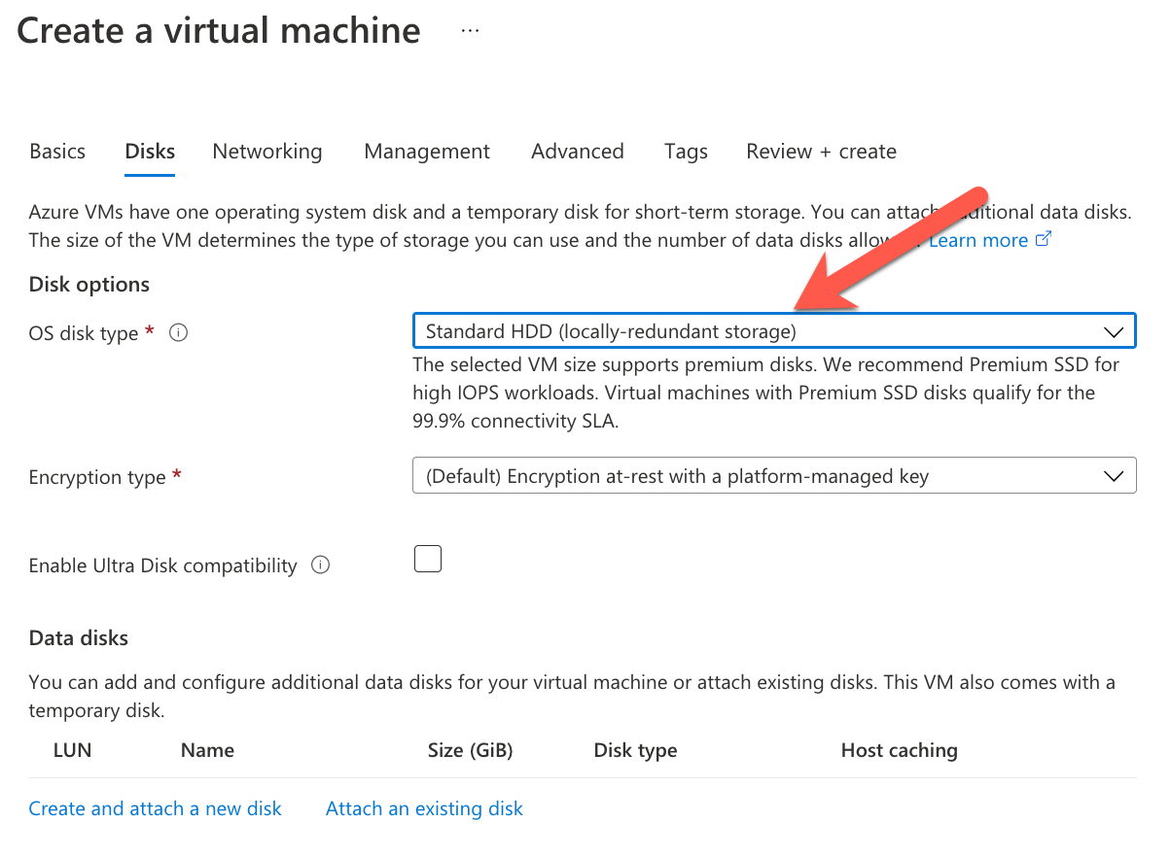
4. Press "Next: Networking>"  
   Fill out the page like this:  
   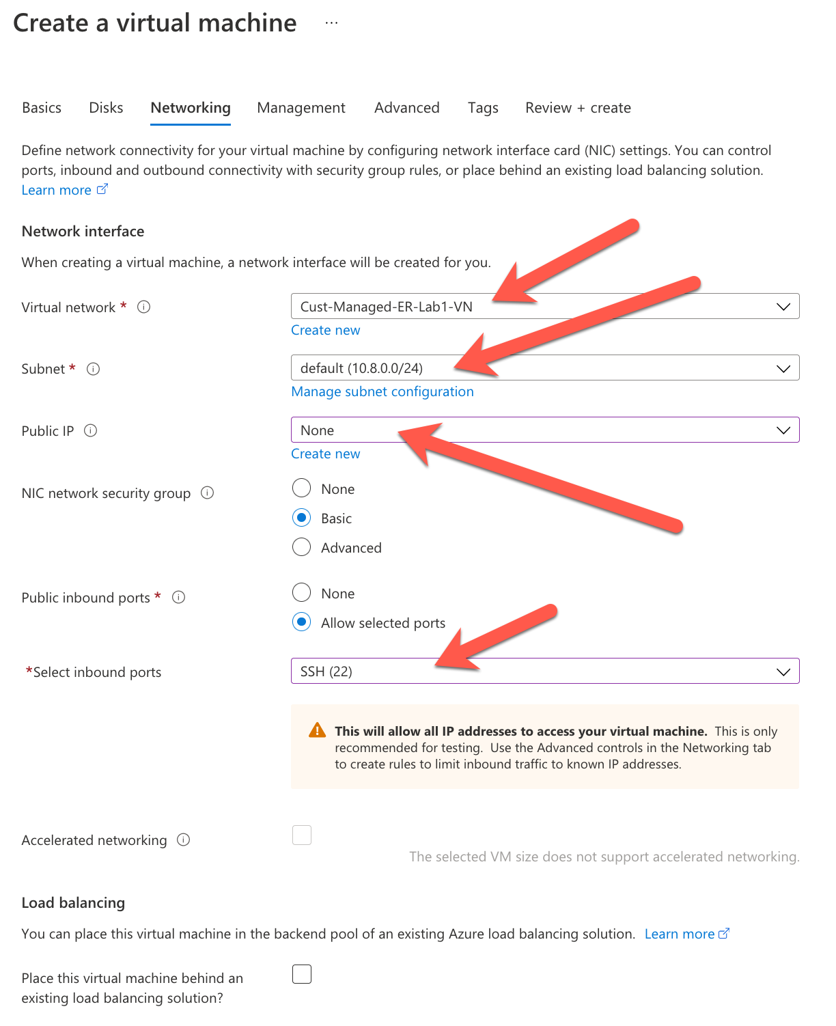
5. Click "Next: Management>"  
   Fill out the page like this:  
   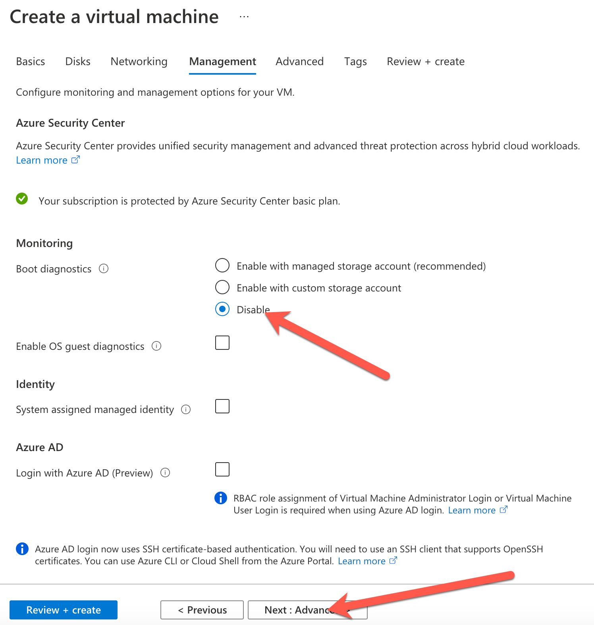
6. Click "Next: Advanced>"  
   Make no changes on the advanced page:  
   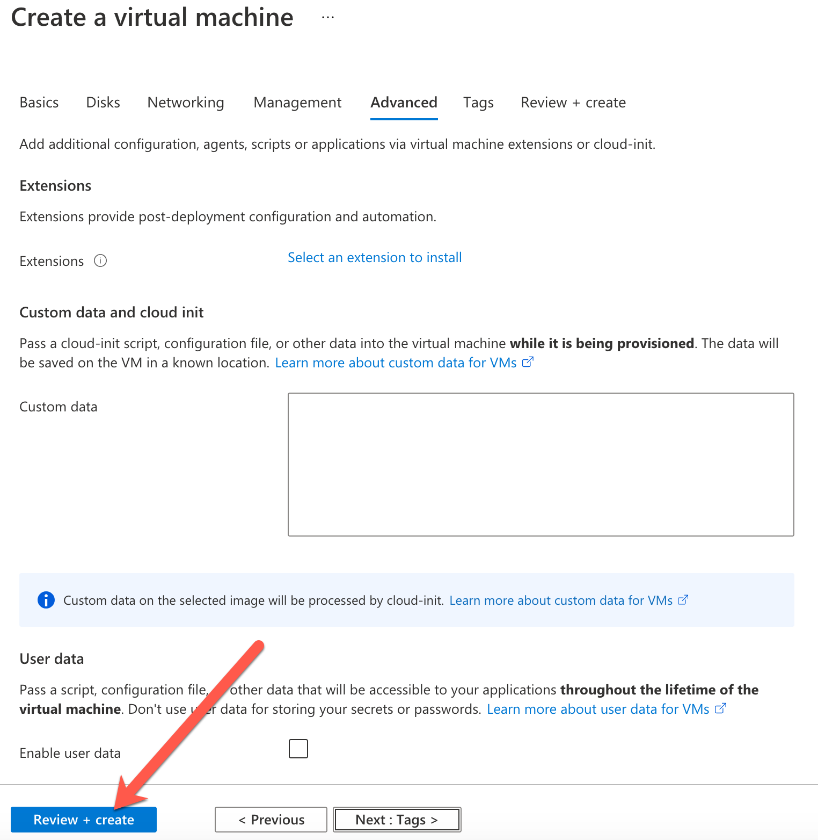
7. Click "Revew + Create"  
   When the validation page appears, click "Create"  
   When deployment is finished, click on "Go to Resource"
8. Once the VM is created note the "Private IP Address". This is the address we will use to ping from the AIX LPAR:  
   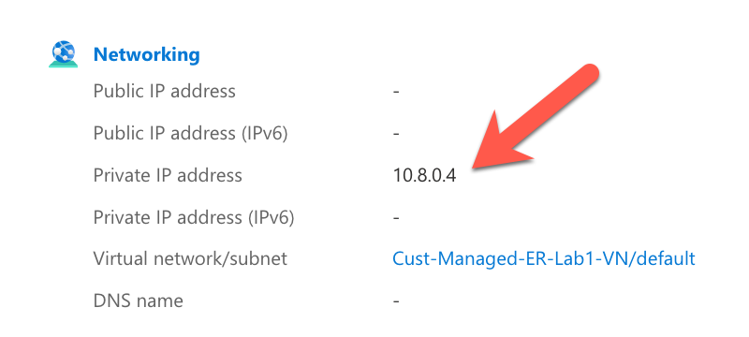
9. Return to the Skytap portal, click on your environment that contains your AIX LPAR. Then "click" on the green screen:  
   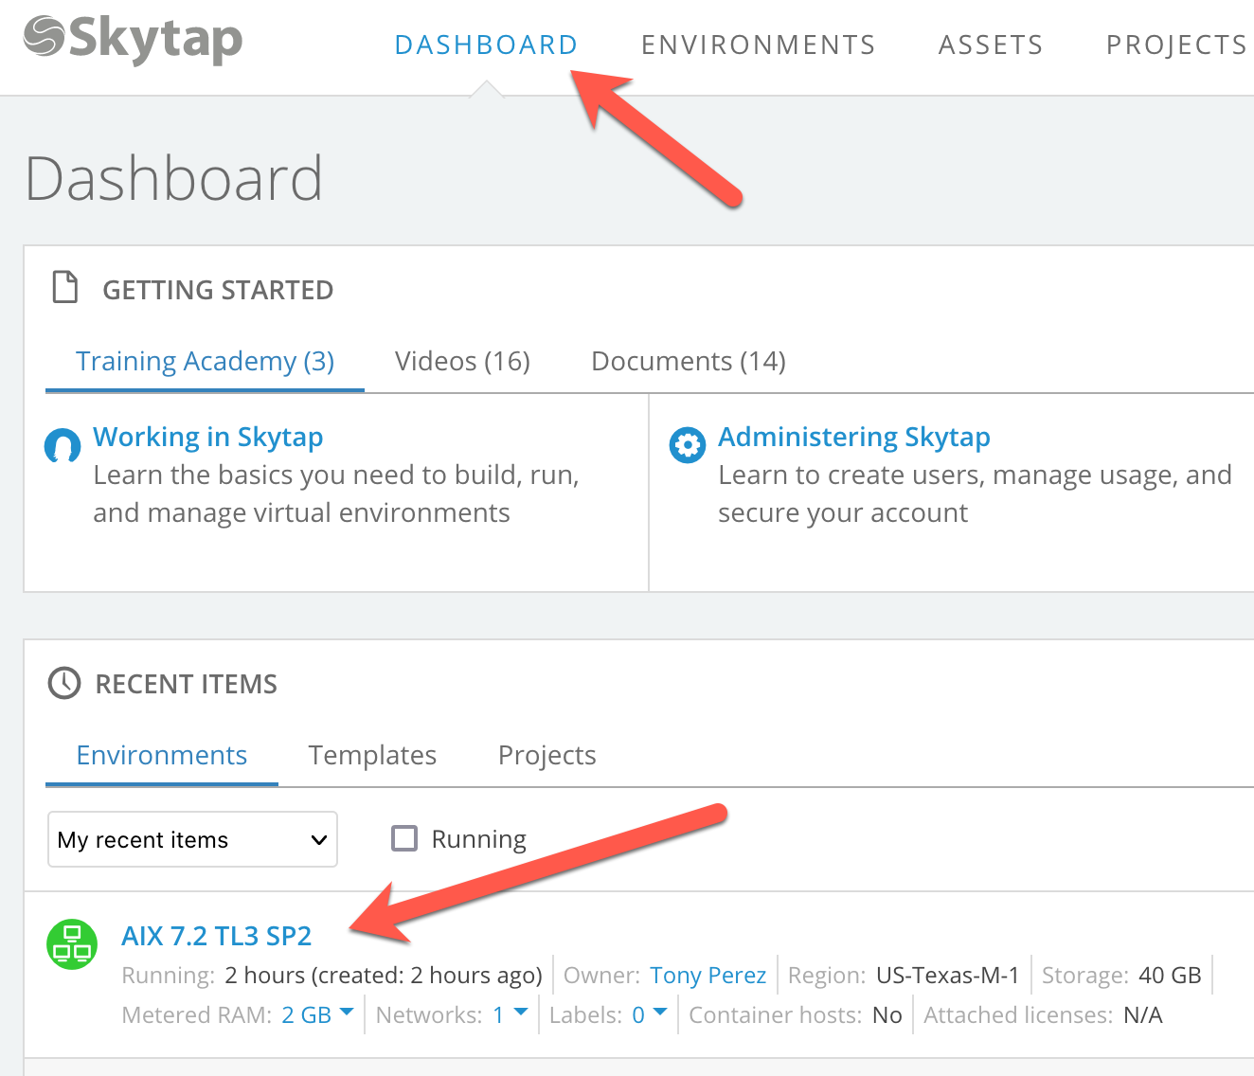  
   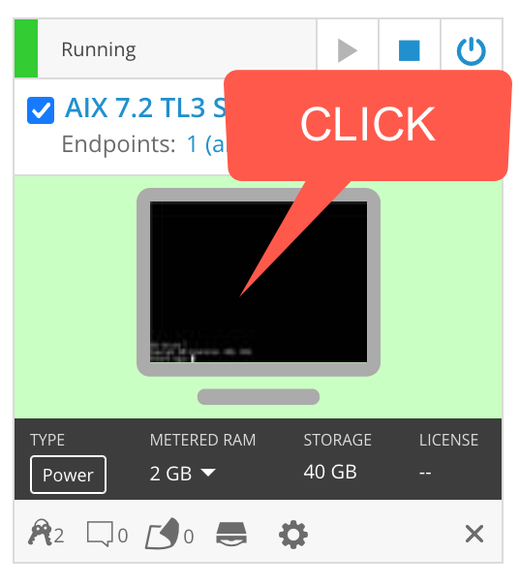
10. Login using the default values of the sample LPAR:  
    The default user and password:
11. 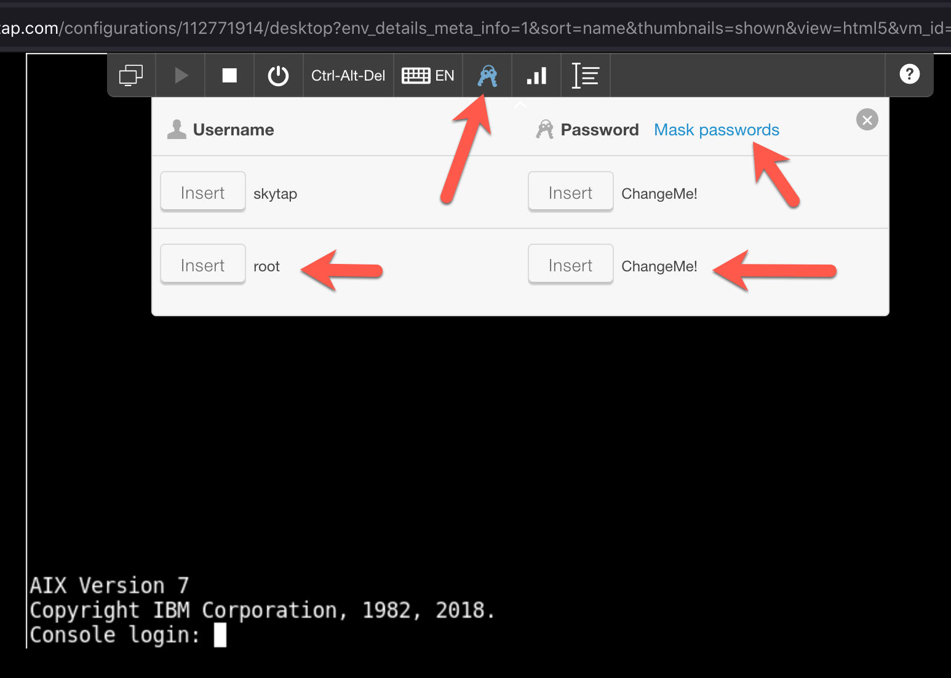  
    Note: you will have to set a new password after the first login.
12. Finally, ping the Linux VM that is in Azure:  
    # ping 10.8.0.4  
      
    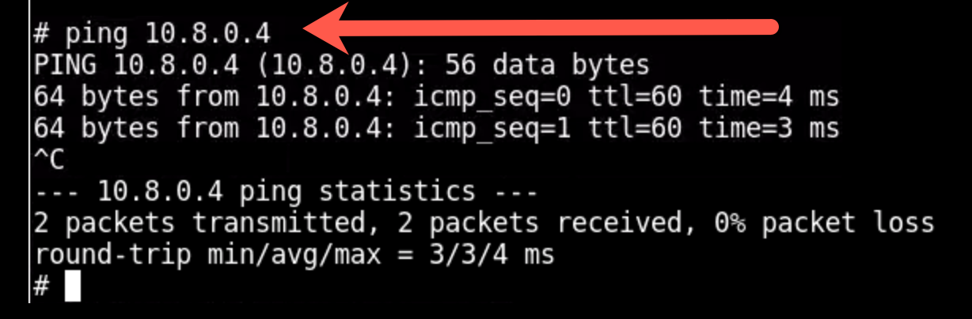
13. Or ssh to it:  
    # ssh skytap@10.8.0.4  
    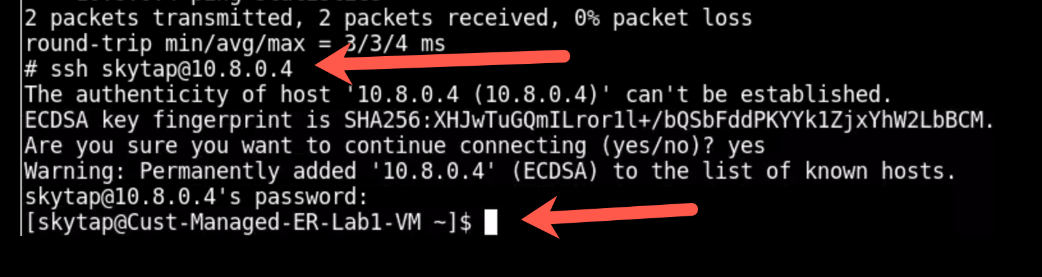
14. END  
      
    This completes the tutorial. You've created an LPAR in Skytap, defined an ExpressRoute end point for your AIX environment, and connected it to other resources running in Azure.  
      
    You should be able to replicate the steps of this tutorial using it as a guide when you do your final production implementation. Substitute the values from your organization into the proper pages.

-------------------------------